**FASHION RENTAL HUB**

### A PROJECT REPORT

#### Submitted by

#### Aditya Bharti (21BCS6514)

#### Vaibhav Verma (21BCS6557)

#### Aastha Khandelwal (21BCS6412)

#### in partial fulfillment for the award of the degree of

**BACHELOR OF ENGINEERING**

###### IN

COMPUTER SCIENCE WITH SPECIALIZATION IN ARTIFICIAL INTELLIGENCE AND MACHINE LEARNING

Under the supervision of Jaswinder Singh



### Chandigarh University

##### **MAY 2024**



**BONAFIDE CERTIFICATE**

#### Certified that this project report “FASHION RENTAL HUB” is the bonafide work of “Aditya Bharti, Vaibhav Verma, Aastha Khandelwal” who carried out the project work under my/our supervision.

###### SIGNATURE

Dr. Aman Kaushik

###### HEAD OF THE DEPARTMENT

AIT-CSE**SIGNATURE**

Mr. Jaswinder Singh

###### SUPERVISOR

Asst. Professor

AIT-CSE

Submitted for the project viva-voce examination held on April 30th, 2024.

INTERNAL EXAMINER EXTERNAL EXAMINER

**TABLE OF CONTENTS**

List of Figures 05

List of Tables 06

Abstract 07

Graphical Abstract 08

Abbreviations 09

Chapter 1: Introduction 12

1.1 Introduction…...........................................................................................................12

1.2 Problem Definition...............................................................................................13

1.3 Problem Overview.....................................................................................................14

1.4 Specifications.............................................................................................................14

1.4.1 Hardware Specification......................................................................................14

### 1.4.2 Software Specification........................................................................................15

### Chapter 2: Literature Survey .........................................................................................16

### 2.1 Existing System...........................................................................................................16

### 2.2 Proposed System.........................................................................................................18

### Chapter 3: Design Flow/Process......................................................................................20

### 3.1 Software Description..................................................................................................20

### 3.1.1 HTML..................................................................................................................20

### 3.1.2 CSS.......................................................................................................................20

### 3.1.3 JAVA SCRIPT....................................................................................................20

### 3.1.4. NODE.JS............................................................................................................21

### 3.1.5. REACT...............................................................................................................22

### 3.1.6. MONGO-DB......................................................................................................23

### 3.1.7. POSTMAN.........................................................................................................24

### 3.2 Problem Formulation.................................................................................................24

### 3.3 Objective......................................................................................................................25

### 3.4 Methodology................................................................................................................26

### Chapter 4: System Analysis.............................................................................................28

### 4.1 ER Diagram.................................................................................................................28

### 4.2 Data Flow Diagram.....................................................................................................29

### 4.3 User Case Diagram.....................................................................................................31

### Chapter 5: Design.............................................................................................................32

### 5.1 Design Goals................................................................................................................32

### 5.2 Concept Generation....................................................................................................32

### 5.3 Architectural Design...................................................................................................33

### 5.3.1 Description of Architectural Design.......................................................................34

### 5.3.2 Shop Products Module............................................................................................34

### 5.3.3 Product Description Module...................................................................................35

### 5.3.4 Shopping Cart Module............................................................................................35

### 5.4 Evaluation & Selection of Specifications/Features..................................................35

### 5.5 Design Constraints Regulations................................................................................36

### 5.6 Manufacturability.......................................................................................................37

### 5.7 Safety, Social &Political Issues Considered in Design............................................39

### 5.8 Analysis and Feature Finalization Subject to Constraints.....................................40

### 5.9 Technical Discussions ................................................................................................41

### Chapter 6: Implementation.............................................................................................42

### 6.1 Database Design and Implementation......................................................................42

### 6.2 User Interface Design and Implementation.............................................................42

### Chapter 7: Results Analysis & Validation.....................................................................49

### 7.1 Result...........................................................................................................................49

### 7.1.1 Challenges...........................................................................................................49

### 7.1.2 Analysis...............................................................................................................50

### 7.2 Validation....................................................................................................................51

### Chapter 8: Conclusion.....................................................................................................52

### 8.1 Conclusion...................................................................................................................52

### 8.1.1 Limitations..........................................................................................................53

### 8.2 Scope for Future Work .............................................................................................53

### References.........................................................................................................................54

# List of Figures

## **Figure 0: Graphical Abstract** ......................................................................................**09**

## **Figure 3.1: HTML CSS & JS**.......................................................................................**21**

## **Figure 3.2: Node.Js Architecture**.................................................................................**22**

## **Figure 3.3: React Architecture**.....................................................................................**23**

## **Figure 3.4: MongoDB Database**...................................................................................**23**

## **Figure 3.5: Postman Logo** .............................................................................................**24**

## **Figure 4.1: Entity Relation Ship Diagram**..................................................................**28**

## **Figure 4.2: Entity Relation Ship Diagram**..................................................................**29**

## **Figure 4.3: A First Level Diagram**...............................................................................**30**

## **Figure 4.4: A Second Level Diagram**...........................................................................**30**

## **Figure 4.5: User Case Diagram**....................................................................................**31**

## **Figure 5.1: Architectural Context Diagram**..............................................................**34**

## **Figure 6.1: Database Diagram**.....................................................................................**42**

# List of Tables

**Table 1.4.2. Software Specification**.........................................................................**15**

# ABSTRACT

# In the ever-evolving landscape of fashion, where trends come and go faster than ever before, the traditional model of purchasing clothing is being challenged by a more sustainable and innovative approach: fashion rental. Enter The Fashion Rental Hub, a pioneering platform that is not only transforming the way we consume fashion but also revolutionizing the entire industry through the power of technology. At the heart of The Fashion Rental Hub lies its state-of-the-art technological infrastructure, built upon the innovative MERN stack. This robust technology stack, comprising MongoDB, Express.js, React.js, and Node.js, forms the foundation of a seamless and intuitive user experience. From dynamic product listings to advanced filtering options, every aspect of the platform is designed to provide users with unparalleled accessibility and convenience. One of the cornerstones of The Fashion Rental Hub is its emphasis on user authentication, ensuring that each user's journey is secure and personalized. Through a streamlined authentication process, users can easily create accounts, manage their profiles, and enjoy a seamless browsing experience tailored to their preferences. The platform boasts a diverse range of clothing options spanning various categories and price points, catering to the diverse tastes and preferences of its users. Whether one is in search of high-end couture for a special occasion or everyday essentials for casual wear, The Fashion Rental Hub offers a curated selection to suit every need. Central to the platform's ethos is its commitment to sustainability and environmental conservation. By promoting renting over buying, The Fashion Rental Hub aims to reduce fashion waste and minimize the carbon footprint associated with clothing production and disposal. Through its innovative model, the platform encourages users to embrace a more sustainable approach to fashion consumption, contributing to a greener and more eco-conscious future. The Fashion Rental Hub is not just a platform for renting clothes; it is a comprehensive ecosystem that offers a personalized shopping experience enhanced by cutting-edge technology. Leveraging the power of artificial intelligence, the platform's recommendation system analyzes user preferences and browsing behavior to provide tailored recommendations, ensuring that every user finds the perfect outfit for any occasion.

# GRAPHICAL ABSTRACT

# 

# Figure 0: Graphical Abstract

**ABBREVIATIONS**

* HTML
* CSS
* JS
* REACT
* MONGODB
* POSTMAN
* EXPRESS

**CHAPTER-1**

**INTRODUCTION**

### INTRODUCTION

### At our Fashion Rental Hub, we pride ourselves on delivering an end-to-end solution that guarantees a seamless experience for every user. From the moment you log in, our user authentication system ensures your security and privacy are safeguarded. Once inside, you'll discover our dynamic product listing feature, which constantly updates to showcase the latest additions to our collection. With advanced filtering options, finding your ideal garment is effortless; whether you're searching by size, color, or style, our platform streamlines the process, ensuring you discover the perfect piece for any occasion. And when it comes time to make a transaction, our secure payment gateway provides peace of mind, ensuring your financial information remains protected throughout the process .In addition to selling clothes, the website will have a dedicated section for clothes donation. Customers can choose to donate their gently used clothes to a charity of their choice or opt for the website's partnered charities. The donated clothes will be collected from the customer's doorstep, and a donation receipt will be provided to them. The website's donation feature will serve as a platform for customers to make a positive impact on society. It will encourage customers to declutter their closets and donate their unused clothes to those in need. By partnering with charities, the website will ensure that the donated clothes reach the intended beneficiaries.To attract customers, the website will run various promotional campaigns such as seasonal sales, festive discounts, and referral programs. The website will also leverage social media platforms to promote its products and services and engage with its customers.In conclusion, the proposed online shopping website with a clothes donation feature aims to provide customers with a seamless online shopping experience while also promoting the culture of giving back to society. By offering high-quality clothing items and a convenient donation feature, the website seeks to attract a large customer base and make a positive impact on society.

## **1.2. PROBLEM DEFINITION**

### Our platform prides itself on offering a user-friendly experience, and our intuitive order summary and dynamic shopping cart facilities are no exception. Managing your rentals has never been simpler: just add your desired items to your cart, review your order summary to ensure everything is as you want it, and proceed to checkout seamlessly. Whether you're browsing our extensive catalog or finalizing your selections, our streamlined process ensures a hassle-free experience from start to finish.

### Furthermore, our AI-based recommendation system adds a touch of personalized convenience to your shopping journey. No more endless scrolling or second-guessing; our system analyzes your preferences and suggests similar products that align with your tastes, making it easier than ever to discover your next favorite piece. With tailored recommendations at your fingertips, finding the perfect addition to your wardrobe is a breeze.

### Finally, the website needs to keep up with the rapidly evolving technology landscape to stay relevant and competitive in the market. Addressing these challenges requires robust security measures, efficient inventory management, reliable shipping options, excellent customer support, and continuous improvement of the website's technology and user experience.

## **1.3. PROBLEM OVERVIEW**

With our intuitive order summary and dynamic shopping cart facility, managing your rentals has never been easier. Simply add your desired items to your cart, review your order summary, and proceed to checkout seamlessly. Plus, our AI-based recommendation system takes the guesswork out of finding your next favorite piece by suggesting similar products tailored to your preferences. Behind the scenes, our complete admin dashboard empowers administrators with valuable insights into product sales and performance metrics. With support for multiple admins, our platform ensures efficient management and oversight, allowing for smooth operations and informed decision-making.

## **1.4. SPECIFICATIONS**

## **1.4.1. Hardware Specification**

* Operations System: Windows 11
* Processor: AMD Ryzen 5 5600H
* Graphic Card: Radeon Graphics 3.30 GHz
* Installed RAM: 8.00 GB

## 

## **1.4.2. Software Specification**

|  |  |
| --- | --- |
| **FRONT-END** | **BACK-END** |
| HTML  CSS  JAVASCRIPT  REACT | MONGODB  POSTMAN  EXPRESS  NODEJS |

**CHAPTER-2**

### LITERATURE SURVEY

### EXISTING SYSTEM

1. Grose, Lynda & Fletcher, Kate. (2012). Fashion and sustainability: Design for Change.
2. Niinimäki, Kirsi & Peters, Greg & Dahlbo, Helena & Perry, Patsy & Rissanen, Timo & Gwilt, Alison. (2020). The environmental price of fast fashion. Nature Reviews Earth & Environment. 1. 189-200. 10.1038/s43017-020-0039-9.
3. Ellen MacArthur Foundation. (2017). A new textiles economy: Redesigning fashion's future.
4. Kadam, Prof & Goplani, Akhil & Mattoo, Shubit & Gupta, Shashank & Amrutkar, Darshan & Dhanke, Jyoti & Kadam, Yogesh. (2023). Introduction to MERN Stack & Comparison with Previous Technologies. European Chemical Bulletin.12.14382-14386. 10.48047/ecb/2023.12.si4.1300.
5. McKinsey & Company. (2022). The future of fashion: A perspective on the industry's digital transformation.
6. Ruan, Yanwen & Xu, Yingjiao & Lee, Hanna. (2022). Consumer Motivations for Luxury Fashion Rental: A Second-Order Factor Analysis Approach. Sustainability. 14. 7475. 10.3390/su14127475.
7. Ting Chi, Victoria Gonzalez, Justin Janke, Mya Phan and Weronika Wojdyla. (2023). The Unveiling the Soaring Trend of Fashion Rental Services: A U.S. Consumer Perspective. Sustainability, 15(19), 14338. urchase Intentions: Does Product Type Matter?" by Seyed Saeed Mousavi, Azizollah Arbabisarjou, and Hamed Kianmehr, published in the Journal of Electronic Commerce Research in 2020. The study examines the impact of online shopping experience on risk perceptions and purchase intentions, and how this varies by product type.

### PROPOSED SYSTEM

Integrating a cloth donation feature and earning points on an online shopping website can be an effective way to promote sustainable practices and incentivize customers to make a positive impact. Here's how this feature could work:

1. Customers can choose to donate their old or unused clothes to a charitable organization or directly to those in need through the website.
2. For each item of clothing donated, customers can earn a certain number of points that can be redeemed for discounts or other rewards on the website.
3. The website can partner with charitable organizations to ensure that the donated clothes go to those in need.
4. The website can also provide information to customers about the environmental benefits of donating clothes and the impact it can have on reducing waste.

***Benefits:***

1. **Promotes sustainability:** By encouraging customers to donate their clothes instead of throwing them away, the online shopping website can promote sustainable practices and reduce waste.
2. **Increases customer engagement:** The cloth donation feature and points system can increase customer engagement and loyalty by providing a unique and meaningful way to earn rewards.
3. **Boosts brand image:** Adding a cloth donation feature can enhance the website's brand image by demonstrating the company's commitment to social responsibility and community outreach.
4. **Supports charitable organizations:** Partnering with charitable organizations can support their efforts to provide clothing to those in need and build positive relationships with the community.
5. **Social impact:** Donating clothes to people in need can have a positive social impact and help address issues related to poverty and inequality. Integrating a cloth donation feature on an online shopping website can make it easier for people to donate their unwanted clothes and contribute to social causes.
6. **Customer loyalty:** By offering a cloth donation feature, online shopping websites can create a sense of social responsibility among their customers. This can help build customer loyalty and strengthen the brand's reputation as a socially responsible business.
7. **Increased website traffic:** Integrating a cloth donation feature on an online shopping website can attract new customers who are interested in donating their clothes to people in need. This can increase website traffic and lead to more sales opportunities.
8. **Cost savings:** Instead of discarding unwanted clothes, customers can donate them through the online shopping website. This can save the customer money on disposal fees and contribute to a more sustainable approach to waste management.
9. **Tax benefits:** By donating clothes to registered charities, customers may be eligible for tax deductions or credits. Integrating a cloth donation feature on an online shopping website can make it easier for customers to receive these benefits and encourage more donations.

**CHAPTER-3**

### DESIGN FLOW/PROCESS

## **3.1 SOFTWARE DESCRIPTION**:

**3.1.1. HTML:**

HTML, or Hypertext Markup Language, is a standard markup language used to create and structure content for the World Wide Web. It is used to create web pages and other types of electronic documents that can be viewed in web browsers.

HTML consists of a series of tags and attributes that are used to define the structure and content of a web page. HTML tags are used to markup different types of content, such as headings, paragraphs, images, and links. Attributes are used to provide additional information about HTML elements, such as the source URL of an image or the destination URL of a hyperlink.

**3.1.2. CSS:**

CSS, or Cascading Style Sheets, is a style sheet language used for describing the presentation of markup languages like HTML. CSS is used to separate the content of a web page from its presentation, allowing web designers to create attractive and consistent styles for web pages.

CSS allows web designers to control the layout, typography, colors, and other visual aspects of a web page. It works by selecting HTML elements and applying styles to them using CSS rules. CSS rules consist of a selector and a declaration block. The selector identifies the HTML element or elements to which the rule should apply, and the declaration block contains the styles to be applied.

**3.1.3. JAVA SCRIPT:**

JavaScript is a popular programming language that is used to create dynamic and interactive web pages. It is a high-level, interpreted language that is designed to be lightweight and easy to use. JavaScript code can be embedded directly into HTML pages or included as separate files.

JavaScript is used to add interactivity to web pages by allowing users to interact with the page elements, such as buttons, forms, and menus. It can also be used to manipulate the Document Object Model (DOM), which represents the structure of a web page.

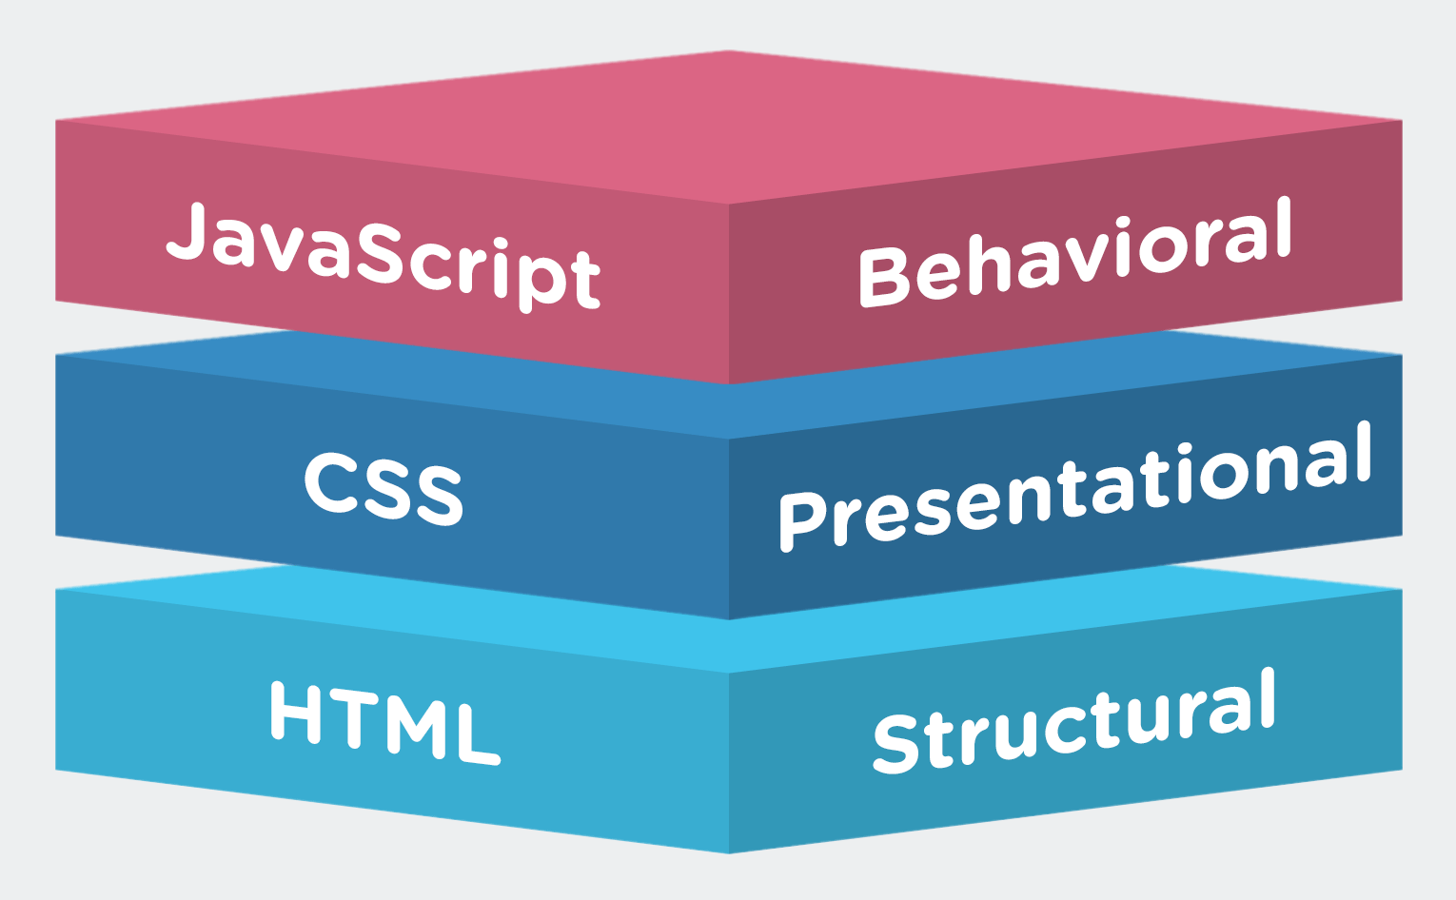

**Figure 3.1: HTML CSS & JS**

**3.1.4. NODE.JS:**

Node.js is an open-source, cross-platform, JavaScript runtime environment that allows developers to run JavaScript code outside of a web browser. It was created by Ryan Dahl in 2009 and has since become a popular tool for building fast and scalable network applications.

Node.js is built on top of the V8 JavaScript engine, which is also used in Google Chrome. It provides a set of built-in modules that make it easy to perform common tasks such as reading and writing files, creating web servers, and making HTTP requests. Node.js also has a large ecosystem of third-party modules that can be easily installed and used in projects.

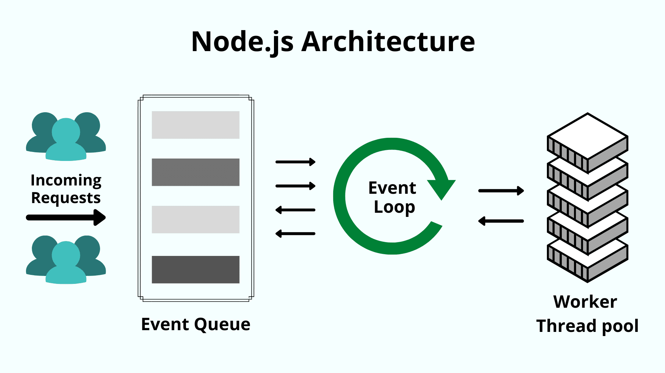

**Figure 3.2: Node.Js Architecture**

**3.1.5. REACT:**

React is a popular open-source JavaScript library for building user interfaces. It was created by Facebook and released to the public in 2013. React allows developers to build complex and interactive user interfaces using a declarative syntax and a component-based approach.

React uses a virtual DOM, which is a lightweight representation of the actual DOM (Document Object Model). This allows React to efficiently update only the parts of the DOM that have changed, without having to re-render the entire page. This can lead to significant performance improvements, especially in complex applications.

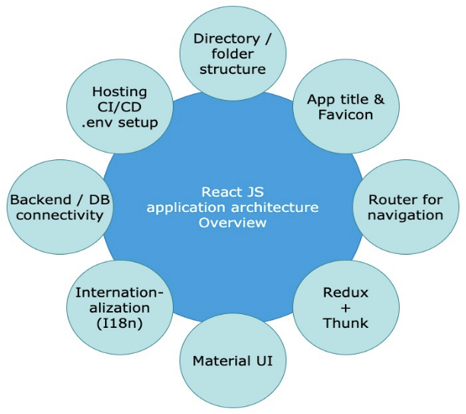

**Figure 3.3: React Architecture**

**3.1.6. MONGO-DB:**

MongoDB is a popular open-source NoSQL database that is designed for modern web applications. It was created in 2007 by the company MongoDB, Inc. and has since become a popular choice for web developers due to its flexibility, scalability, and ease of use.

MongoDB is a document-oriented database, which means that data is stored in a flexible, JSON-like format called BSON. It allows developers to store and access data in a way that is more natural and intuitive than traditional relational databases. MongoDB also supports dynamic schema design, which allows for more flexibility in data modeling and schema evolution.

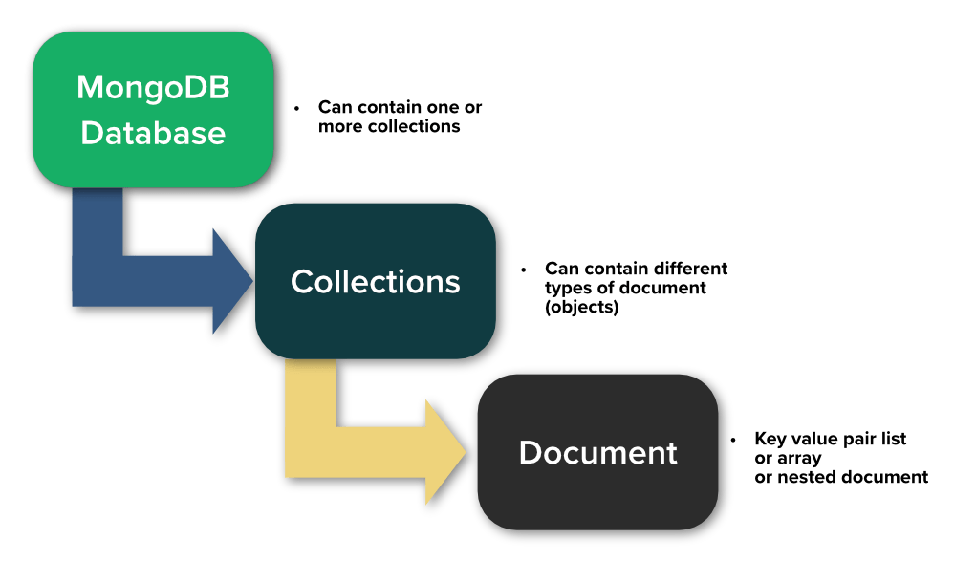

**Figure 3.4: MongoDB Database**

**3.1.7. POSTMAN:**

Postman is a popular API development tool that allows developers to test, debug, and document APIs more efficiently. It provides a user-friendly interface for making API requests, testing API endpoints, and managing API documentation.

Postman supports a wide range of API protocols and formats, including REST, SOAP, GraphQL, and more. It also allows developers to easily create and share collections of API requests, making it easier to collaborate with other team members.

One of the key features of Postman is its ability to automate API testing. Developers can create automated test scripts using JavaScript or other scripting languages, allowing them to quickly and easily test API endpoints and ensure that they are working as expected.



**Figure 3.5: Postman Logo**

# 

# 

## **3.2 PROBLEM FORMULATION:**

The problem formulation for in an online shopping website can be framed as follows:

1. How to effectively incentivize customers to donate their old or unused clothes through an online shopping website?
2. How to ensure that the donated clothes go to reputable charitable organizations or directly to those in need?
3. How to store and manage the donated clothes to ensure efficient processing and distribution?
4. How to measure the impact of the cloth donation and earning points feature on the website's sustainability goals and customer engagement?
5. How to balance the costs and benefits of implementing the feature, and ensure that it does not negatively impact the website's profitability?
6. How to effectively communicate the benefits of the feature to customers and promote its adoption?
7. How to design the feature to be user-friendly, accessible, and intuitive, and ensure that it integrates seamlessly with the website's existing features and systems?

## **3.3 OBJECTIVE:**

Integrating a cloth donation and earning points feature in an online shopping website can have several objectives, including:

1. **Encouraging sustainability:** By allowing customers to donate their unwanted clothes instead of throwing them away, the online shopping website can promote sustainability and reduce waste. This can be a key objective for businesses that are committed to reducing their environmental impact.
2. **Building customer loyalty:** By offering a cloth donation and earning points feature, the online shopping website can incentivize customers to keep coming back and make more purchases. This can help build customer loyalty and increase customer retention rates.
3. **Promoting social responsibility:** The cloth donation feature can also promote social responsibility and help the online shopping website build a positive brand image. Customers may be more likely to shop at a business that is committed to making a positive social impact.
4. **Supporting charitable causes:** By partnering with charitable organizations, the online shopping website can support causes that align with its values and mission. This can help build relationships with community organizations and support social causes that are important to the business.
5. **Increasing website traffic:** By offering unique features such as cloth donation and earning points, the online shopping website can attract new customers and increase website traffic. This can lead to more sales opportunities and revenue growth.

Overall, integrating a cloth donation and earning points feature in an online shopping website can have several objectives that align with the values and goals of the business. It can help promote sustainability, build customer loyalty, support charitable causes, and increase website traffic.

**3.4 METHODOLOGY:**

The methodology used in developing an online shopping website may vary depending on the specific requirements and goals of the website. However, here are some common steps that may be involved:

1. **Requirement gathering:** This involves understanding the requirements of the website, such as the features, functionalities, and target audience.
2. **Planning:** This involves creating a roadmap for the development of the website, including timelines, resources, and budget.
3. **Design:** This involves creating wireframes, prototypes, and user interfaces for the website, ensuring a visually appealing and user-friendly design.
4. **Development:** This involves writing code to build the website, incorporating the features and functionalities required.
5. **Testing:** This involves testing the website to ensure that it is functioning as intended, identifying and resolving any bugs or issues.
6. **Deployment:** This involves launching the website, making it available to the public.
7. **Maintenance:** This involves ongoing maintenance of the website, ensuring that it remains functional and up-to-date with the latest technologies.

Overall, integrating a cloth donation and earning points feature in an online shopping website requires careful planning, design, development, testing, launch, monitoring, and evaluation. By following a structured methodology, the feature can be implemented effectively and help to promote social responsibility and sustainable practices.

**CHAPTER-4**

### SYSTEM ANALYSIS

**4.1 ER DIGRAM:**

After carefully analyzing the requirements and functionality of the web application, I had two important diagrams by the end of the analysis phase. They are the ER diagram and data flow diagram which were the basis for finding out entities and relationships between them, the flow of information.

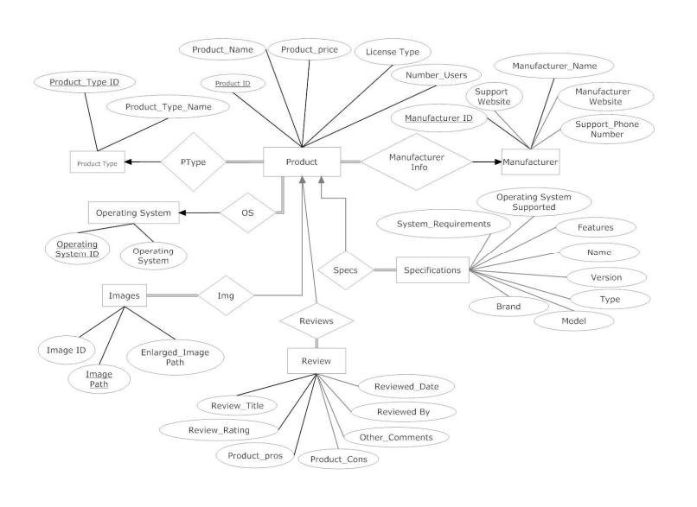

**Figure 4.1: Entity Relation Ship Diagram**

**4.2 DATA FLOW DIGRAM:**

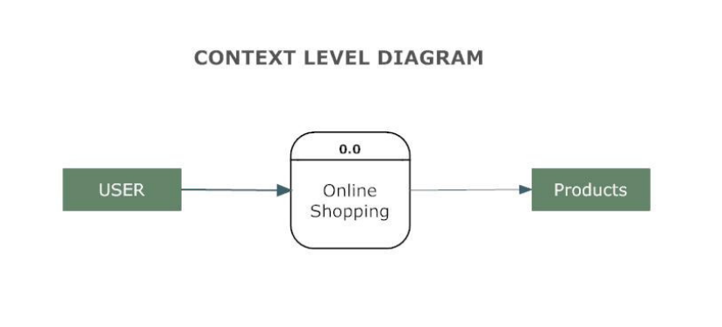

**Figure 4.2: Entity Relation Ship Diagram**

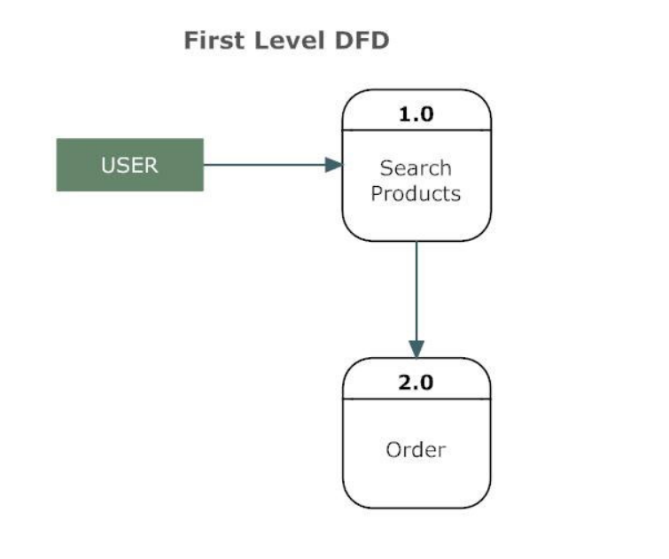

**Figure 4.3: A First Level Diagram**

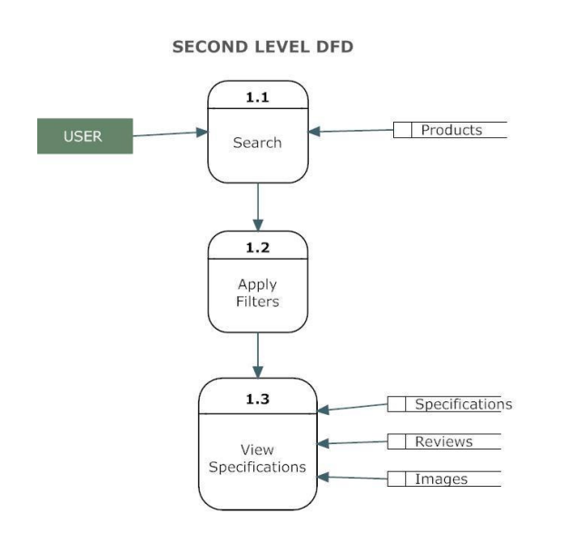

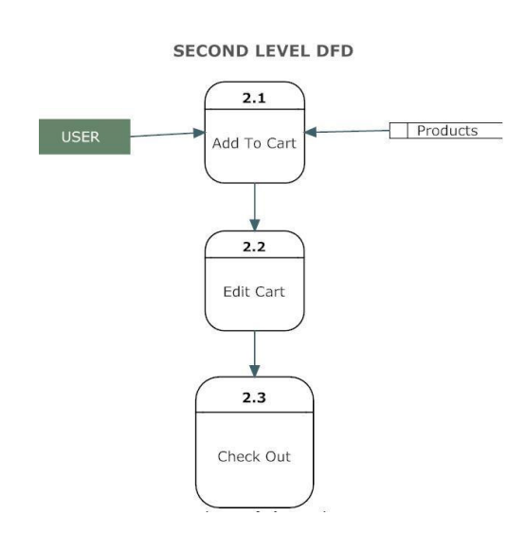

**Figure 4.4: A Second Level Diagram**

**4.3 USER CASE DIAGRAM:**

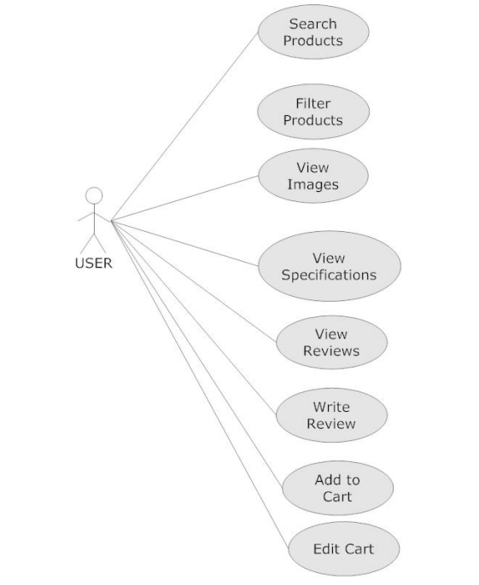

**Figure 4.5: User Case Diagram**

**CHAPTER-5**

### DESIGN

### 5.1 DESIGN GOALS

### • The design of the web application involves the design of the forms for listing the products, search for products, display the complete specification for the product, and design a shopping cart that is easy to use.

### • Design of an interactive application that enables the user to filter the products based on different parameters.

### • Design of an application that has features like drag and drop etc.

### • Design of application that decreases data transfers between the client and the server.

### 5.2 CONCEPT GENERATION

**1. Personalized product recommendations:** One way to improve the online shopping experience is to use artificial intelligence algorithms to suggest products based on a customer's previous purchase history, search history, and browsing behavior.

**2. Virtual Try-On:** Implementing virtual try-on technology allows customers to see how clothes or accessories look on them before making a purchase.

**3. Voice-Activated Shopping:** The ability to shop online using voice commands would make the shopping experience faster, more convenient, and hands-free.

**4. Social Media Integration:** Integrating social media with online shopping platforms can help shoppers discover new products and connect with other users to get recommendations and share experiences.

**5. Augmented Reality:** Augmented reality technology allows shoppers to visualize how products such as furniture or home decor will look in their own space before making a purchase.

**6. Live Chat Support:** Providing real-time chat support can help customers get answers to their questions and resolve issues quickly and efficiently.

**7. Subscription Services:** Subscription services are a popular trend in online shopping, where customers can have regularly scheduled shipments of products they frequently use, such as groceries or personal care items.

**8. Personalized Discounts and Promotions:** Providing personalized discounts and promotions based on a customer's purchase history, preferences, and behavior can encourage repeat business and boost customer loyalty.

**9. Mobile-Friendly Interface:** With the rise of mobile devices, it's essential to have a mobile-friendly interface for online shopping platforms, allowing customers to shop on the go.

**10. Same-Day Delivery:** Providing same-day delivery for products can be a game-changer for online shopping, offering customers a fast and convenient way to get their purchases.

### 5.3 ARCHITECTURAL DESIGN

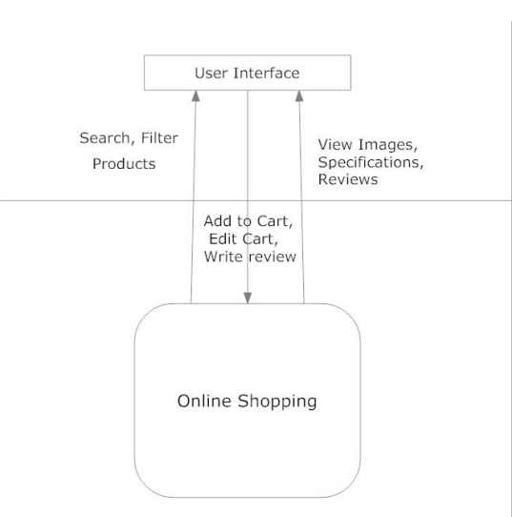

**Figure 5.1: Architectural Context Diagram**

**5.3.1 Description of Architectural Design**

In this context diagram, the information provided to and received from the ‘Online Shopping’ is identified. The arrows represent the information received or generated by the application. The closed boxes represent the set of sources and sinks of information.

In the system, we can observe that the user interacts with the application through a graphical user interface. The inputs to the system are the Search and Filter criteria provided by the user and a new review written by the user. Also, the output is in the form of Repeater and grid views which present the users with list of Products available. The users can view complete specification, view Images and reviews by other users.

**5.3.2 Shop Products Module**

This module starts when the user visits the home page or when a user searches for a product by entering a search term. This part of the application includes displaying all the products that are available or the products that match the search term entered by the user. The user can then filter these products based on various parameters like manufacturer, product type, operating system supported or a price range. The user browse through the products and each product would be displayed with an image and its features like operating system supported, number of user licenses and if it is a full version or an upgrade version. A user can add a product to the cart either by dragging the product and dropping it in the cart or by clicking a button. The user would be able to see the shopping cart summary.

**5.3.3 Product Description Module**

This module starts when a user visits the product description page. A user can view various images of the product of different sizes. The use can see an enlarged image in a popup window. The user can view the complete specification of the product like its features, operating system supported, system requirements etc. A user can also view the manufacturer information and also information about rebates, exchange policies etc. A user can also view the reviews of the product. A user can also write a review for the product.

**5.3.4 Shopping Cart Module**

This module starts when the user views the shopping cart. All the products that have been added to the shopping cart by the user are listed along with their price and the quantity. The total price of all the products added to cart is displayed. A user can edit the quantity of each product or remove the product from the shopping cart. A user can remove the product from the cart by clicking a button or by dragging the product and dropping it outside the cart. The total price changes accordingly when a user edits the quantity of a product or when a product is removed from the cart.

### 5.4 EVALUATION & SELECTION OF SPECIFICATIONS/FEATURES

When evaluating and selecting specifications/features of an online shopping platform, there are several factors to consider. Here are some important ones:

**1. User Interface:** The user interface should be intuitive and easy to navigate, allowing customers to find what they're looking for quickly and easily. It should also be visually appealing and consistent throughout the platform.

**2. Security:** Security is crucial for online shopping, and the platform should have robust measures in place to protect customers' personal and financial information. SSL encryption, two-factor authentication, and other security protocols should be implemented.

**3. Payment options:** The platform should offer a range of payment options to accommodate different customers' preferences. Popular options include credit/debit cards, PayPal, Apple Pay, and Google Pay.

**4. Product search and filtering:** Customers should be able to search for products easily and effectively, with filtering options such as size, colour, price, and brand.

**5. Product descriptions and images:** Product descriptions should be clear and detailed, with high-quality images that accurately represent the product. This helps customers make informed decisions about what they're buying.

**6. Shipping and delivery options:** Customers should have a variety of shipping and delivery options to choose from, including same-day delivery, next-day delivery, and free shipping for orders over a certain amount.

**7. Customer support:** A robust customer support system should be in place, with options such as live chat, email support, and phone support. Support should be available 24/7 to address any issues or concerns customers may have.

**8. Return and refund policy:** The platform should have a clear and fair return and refund policy that is easy for customers to understand and follow.

**9. Personalization:** Personalization features, such as product recommendations based on purchase history or browsing behaviour, can improve the customer experience and increase sales.

**10. Reviews and ratings:** The platform should allow customers to leave reviews and ratings for products, helping other customers make informed decisions and fostering a sense of community.

### 5.5 DESIGN CONSTRAINTS– REGULATIONS

When designing an online shopping platform, it's important to be aware of the regulations and laws that apply to online commerce. Here are some key design constraints to consider:

**1. Data protection regulations:** Online shopping platforms must comply with data protection regulations such as GDPR (General Data Protection Regulation) or CCPA (California Consumer Privacy Act) that govern how customer data is collected, stored, and used.

**2. Consumer protection laws:** Online shopping platforms must comply with consumer protection laws such as the Consumer Protection Act, which covers issues such as the right to cancel an order, refunds, and warranties.

**3. Payment Card Industry Data Security Standards (PCI DSS):** The Payment Card Industry Data Security Standards must be followed to ensure the secure processing of credit card payments.

**4. Accessibility requirements:** Online shopping platforms must comply with accessibility requirements set by laws such as the Americans with Disabilities Act (ADA), ensuring that users with disabilities can access and use the platform.

**5. Intellectual property laws:** Online shopping platforms must comply with intellectual property laws such as copyright and trademark laws, ensuring that they do not infringe on the rights of others.

**6. Tax laws:** Online shopping platforms must comply with tax laws, including collecting and remitting sales tax, GST and other taxes.

**7. E-commerce regulations:** There are specific e-commerce regulations that apply to online shopping, such as the E-commerce Directive in the EU, which covers issues such as information requirements, consumer rights, and electronic contracts.

**8. Advertising and marketing regulations:** Online shopping platforms must comply with advertising and marketing regulations, including rules regarding claims, disclosures, and endorsements.

**9. Anti-spam laws:** Online shopping platforms must comply with anti-spam laws such as the CAN-SPAM Act, which governs the use of email marketing and requires certain disclosures and opt-out mechanisms.

**10. Import and export regulations:** Online shopping platforms must comply with import and export regulations, ensuring that products are properly labelled, licensed, and shipped in compliance with applicable laws and regulations.

### 5.6 MANUFACTURABILITY

Manufacturability in online shopping refers to the ability to produce products efficiently and cost-effectively. While manufacturing may not be directly related to online shopping, there are several factors to consider to ensure manufacturability when designing and selling products online. Here are some key considerations:

**1. Design for manufacturing:** Products should be designed with manufacturability in mind, using materials and manufacturing processes that are cost-effective and efficient.

**2. Scalability:** Online shopping platforms should be designed to handle large volumes of orders, with the ability to scale up production as demand increases.

**3. Supply chain management:** Supply chain management is critical for manufacturability, with a focus on optimizing inventory levels, reducing lead times, and ensuring timely delivery of materials.

**4. Quality control:** Quality control measures should be in place to ensure that products meet the desired quality standards and are free from defects or issues.

**5. Product customization:** While customization is an important feature of online shopping, it can also create challenges for manufacturability. Products should be designed to allow for customization without significantly increasing production costs.

**6. Packaging and shipping:** Packaging and shipping should be designed to minimize waste and reduce shipping costs while ensuring that products are delivered safely and efficiently.

**7. Automation:** Automation can help streamline manufacturing processes and reduce costs, particularly for high-volume products. Online shopping platforms should consider incorporating automation into their manufacturing processes.

**8. Environmental sustainability:** Online shopping platforms should consider the environmental impact of their products and manufacturing processes, designing products that are eco-friendly and using sustainable manufacturing practices wherever possible.

**9. Collaboration with manufacturers:** Collaboration between online shopping platforms and manufacturers is essential for ensuring manufacturability. Clear communication, sharing of information, and working together to optimize manufacturing processes can lead to more efficient and cost-effective production.

**10. Continuous improvement:** Online shopping platforms should continually review and improve their manufacturing processes to increase efficiency, reduce costs, and improve product quality. This can include implementing new technologies, optimizing supply chain management, and exploring new manufacturing methods.

### 5.7 SAFETY, SOCIAL &POLITICAL ISSUES CONSIDERED IN DESIGN

When designing an online shopping platform, it's important to consider various safety, professional, ethical, social, and political issues. Here are some key issues to consider:

**1. Safety:** Online shopping platforms should prioritize the safety and security of users' personal information, financial information, and transactions. Measures should be in place to prevent hacking, data breaches, and identity theft.

**2. Professionalism:** Online shopping platforms should maintain a professional image, with clear and concise communication, a user-friendly interface, and reliable customer service.

**3. Ethical considerations:** Online shopping platforms should ensure ethical behaviour, including fair pricing, truthful product descriptions, and ethical sourcing and manufacturing practices.

**4. Social issues:** Online shopping platforms should consider social issues such as diversity, equity, and inclusion. The platform should be accessible to all users, regardless of their background, race, gender, or other characteristics.

**5. Political issues:** Online shopping platforms should consider political issues such as regulations and laws that may impact the platform's operations, such as data protection laws, consumer protection laws, and tax laws.

**6. Sustainability:** Online shopping platforms should consider the environmental impact of their operations, including the sourcing of materials, manufacturing processes, packaging, and shipping. Efforts should be made to minimize waste and reduce the carbon footprint.

**7. Privacy:** Online shopping platforms should prioritize user privacy, with clear policies on data collection, storage, and use. Users should have control over their personal information and the ability to opt-out of data collection and marketing activities.

**8. Security:** Online shopping platforms should have robust security measures in place to prevent cyber-attacks and protect users' data and financial information.

**9. Fraud prevention:** Online shopping platforms should have measures in place to prevent fraud, such as authentication and verification processes and monitoring for suspicious activity.

**10. Customer service:** Online shopping platforms should prioritize excellent customer service, with responsive support for users who have questions or issues with their orders.

### 5.8 ANALYSIS AND FEATURE FINALIZATION SUBJECT TO CONSTRAINTS

When finalizing the features of an online shopping platform, it's essential to consider the constraints that may impact their development and implementation. These constraints include technical, time, budget, legal, user, business, scalability, data, resource, and security constraints.

Technical constraints may limit the features that can be implemented on older devices or slower internet connections. Time constraints may impact the development timelines, which can be affected by resource availability, project scope, and stakeholder expectations. Budget constraints may affect the platform's ability to implement certain features, as development costs, server costs, and marketing expenses must be considered. Legal constraints must also be considered, as regulations and laws may impact the platform's operations.

User constraints refer to the needs and preferences of the platform's users, which can be identified through user research and user testing. Business constraints refer to the platform's business model, revenue streams, and competitive landscape, which the platform's features must align with. Scalability constraints refer to the platform's ability to handle increasing user demand, and features should be designed with scalability in mind.

Data constraints refer to limitations on the amount and types of data that the platform can collect and use, and data privacy regulations must be considered when developing new features. Resource constraints refer to limitations in human resources, including the number of developers, designers, and support staff available to work on the platform. Finally, security constraints refer to the need to protect user data, financial information, and transactions from cyber threats, and features should be designed with robust security measures in place.

**5.9 TECHNICAL DISCUSSIONS**

The products can be filtered based on various parameters like Manufacturer, Product Type, Operating System supported etc. Initially it was decided to have the various list items predefined. But with time new manufacturers and product types could be added. So the values for the list of manufacturers and product types are loaded dynamically by retrieving from the database.

Also, it was decided initially to have a drop-down list for price range and the user could select a price range from the ranges available. But this would limit the user’s ability to filter the products based on different price ranges. Instead providing two text fields so that the user can enter their price range would give them more flexibility.

A product could be added to a shopping cart by dragging it and dropping it in the cart area. Items in the cart could be removed by clicking a button. To maintain symmetry and ease of use products could be removed from the cart by dragging the product out of the cart.

A product can be added to the cart by dragging it and dropping it in the cart. Initially it was decided that when a product is dropped in the cart the cart summary label could be updated on the client side without any call to the server and later the session variables (Shopping cart) could be updated. This would result in loss of information when the user loses internet connection.

So when a product is dropped in the cart area a web service is called and this service updates the session variables for the shopping cart and the cart summary is recalculated and sent back to the client. This would improve the reliability of the application.

**CHAPTER-6**

**IMPLEMENTATION**

**6.1 DATABASE DESIGN AND IMPLEMENTATION**

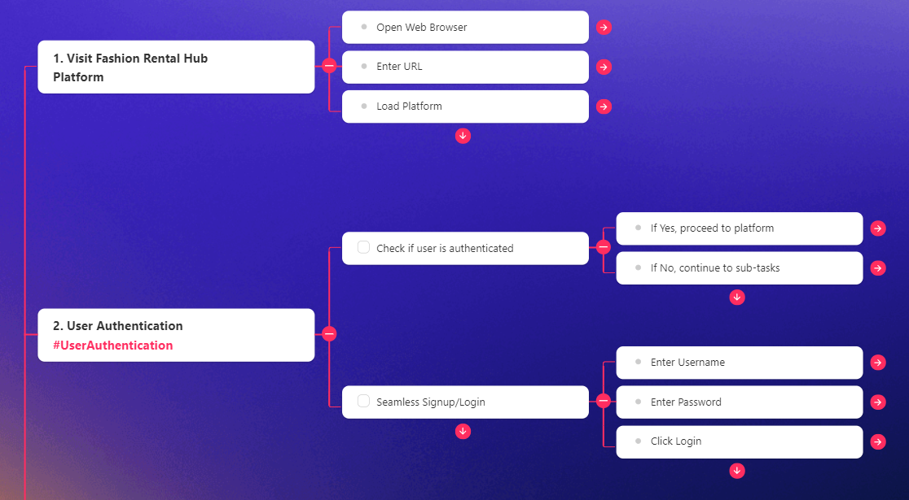

**Figure 6.1: Database Diagram**

**6.2 USER INTERFACE DESIGN AND IMPLEMENTATION**

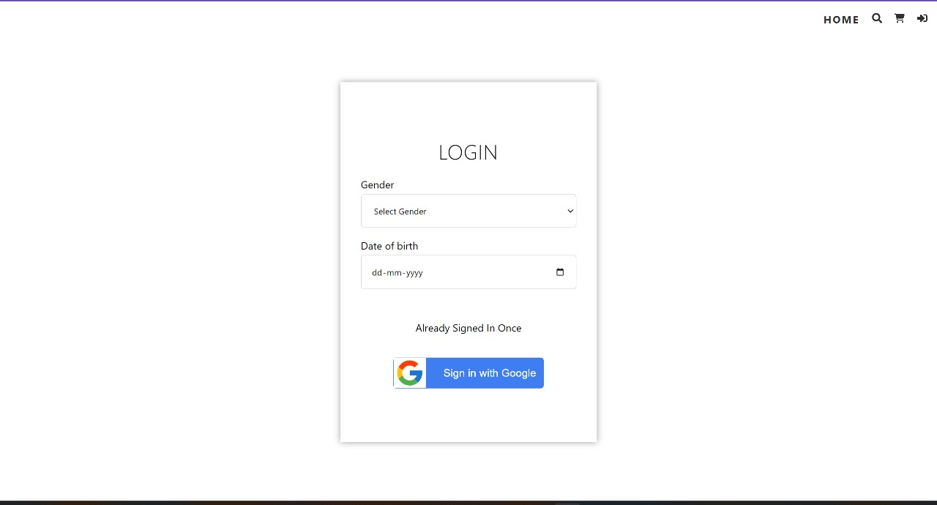

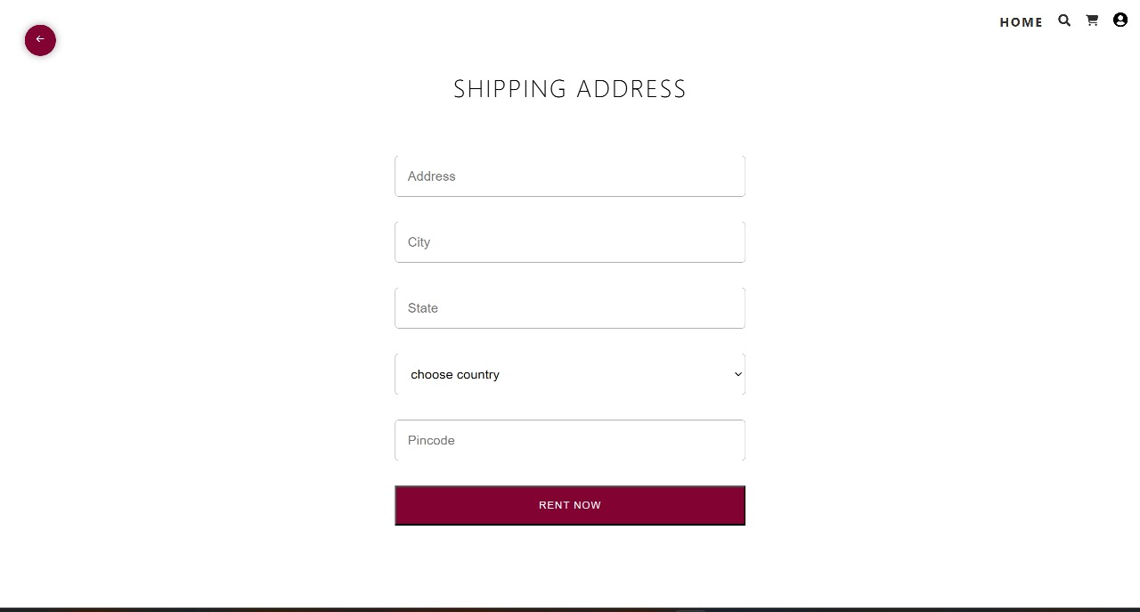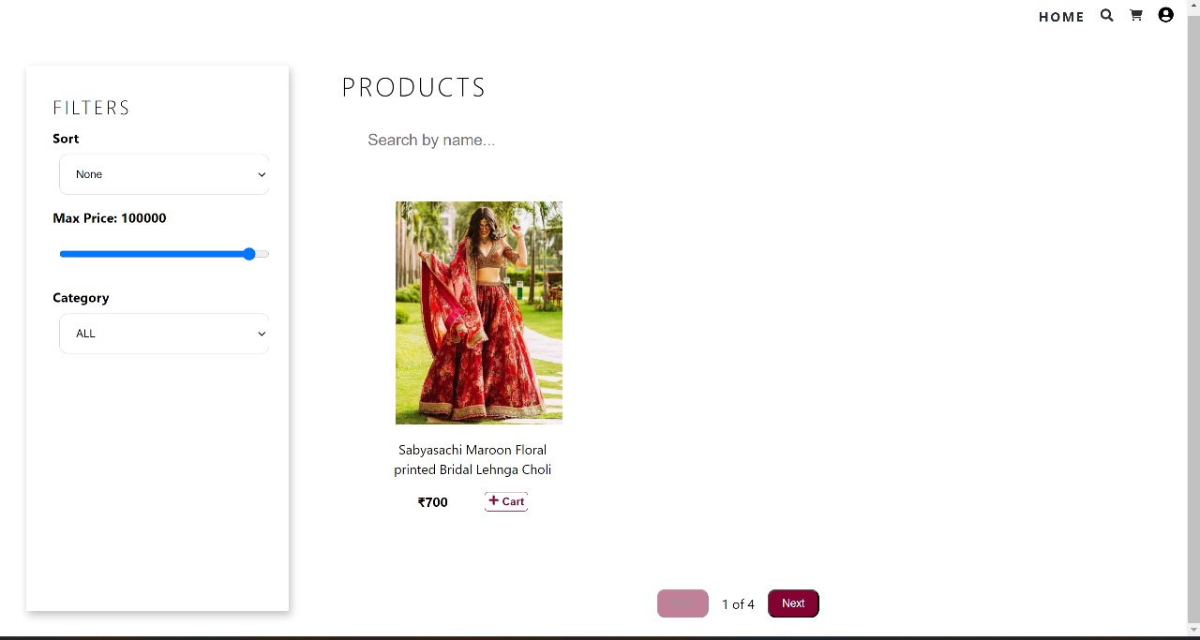

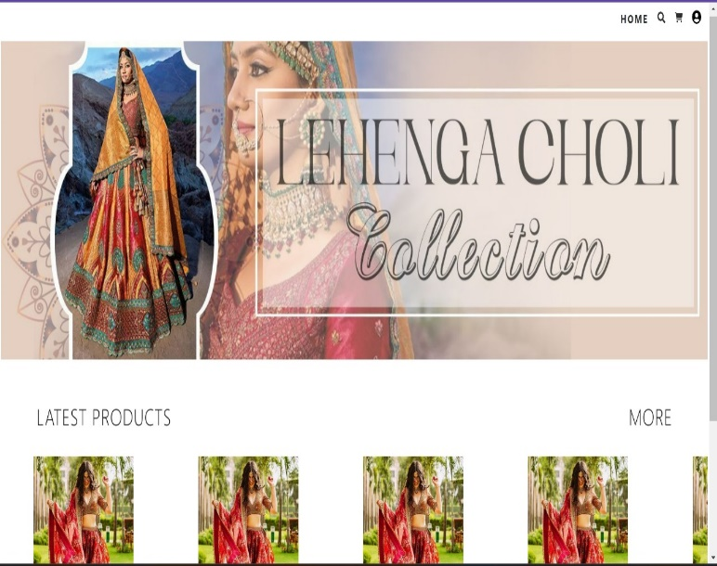

**CHAPTER-7**

**RESULTS ANALYSIS & VALIDATION**

**7.1 RESULT**

The application can be used for any Ecommerce application. It is easy to use, since it uses the GUI provided in the user dialog. User friendly screens are provided. The application is easy to use and interactive making online shopping a recreational activity for users. It has been thoroughly tested and implemented.

**7.1.1 Challenges**

• Compatibility with browsers like Mozilla Firefox, Internet explorer, Chrome etc.

• Using a layered approach in developing the application which would make the application maintainable.

• Learning new technologies like using JavaScript for drag and drop behavior and Ajax toolkit controls with little guidance.

The overall idea of doing this project is to get a real time experience. Learn new technologies.

**7.1.2 Analysis**

To analyze the results of an online shopping website, you should consider the following key metrics:

* **Traffic sources:** Determine the sources of traffic to your website, such as search engines, social media, or email marketing. Analyze which sources bring the most traffic and which ones bring the most conversions.
* **Conversion rate:** Determine the percentage of website visitors who convert into customers. Calculate the conversion rate for each traffic source, landing page, and product category. Analyze the factors that may impact the conversion rate, such as website design, user experience, pricing, and product quality.
* **Average order value:** Determine the average amount of money spent by customers per order. Analyze the factors that may influence the average order value, such as product pricing, discounts, and promotions.
* **Cart abandonment rate:** Determine the percentage of customers who add items to their cart but do not complete the purchase. Analyze the factors that may impact the cart abandonment rate, such as website speed, checkout process, shipping costs, and payment options.
* **Customer retention rate:** Determine the percentage of customers who return to make a repeat purchase. Analyze the factors that may influence the customer retention rate, such as customer service, product quality, and loyalty programs.
* **Customer feedback:** Collect customer feedback through surveys, reviews, and social media. Analyze the feedback to identify customer needs, preferences, and pain points. Use the feedback to improve the website, products, and customer service.
* **Revenue and profit:** Determine the revenue and profit generated by the website. Analyze the revenue and profit by traffic source, product category, and customer segment. Use the data to identify the most profitable products and customers.

To effectively analyze the results of an online shopping website, you should use web analytics tools such as Google Analytics, Adobe Analytics, or Mixpanel. These tools can help you track and analyze the key metrics and generate reports and dashboards to visualize the data. Use the insights gained from the analysis to optimize the website, improve the user experience, and increase revenue and profitability.

**7.2 VALIDATION**

To validate an online shopping website, you can use various techniques such as A/B testing, customer surveys, and website analytics tools. Here are some ways to validate an online shopping website:

* **A/B testing:** A/B testing involves creating two versions of a web page and testing them against each other to see which one performs better. You can test different website elements such as website design, product pricing, promotions, and call-to-action buttons. By analyzing the A/B testing results, you can determine which version of the website performs better and make data-driven decisions to improve the website.
* **Customer surveys:** You can conduct customer surveys to collect feedback on the website's usability, product offerings, and customer service. Surveys can provide insights into customer needs, preferences, and pain points. Use the survey results to improve the website and address customer issues.
* **Website analytics tools:** Use website analytics tools such as Google Analytics to track and analyze website metrics in real-time. These tools can provide insights into website traffic, user behavior, conversion rates, and customer demographics. Use the data to optimize the website, improve the user experience, and increase revenue and profitability.
* **User testing:** Conduct user testing with real customers to observe how they interact with the website. User testing can help you identify usability issues, navigation problems, and other website-related issues. Use the user testing results to improve the website and provide a better user experience.

By using these validation techniques, you can ensure that your online shopping website is meeting the needs of your customers and providing a positive user experience. Use the insights gained from validation to make data-driven decisions and continuously improve the website.

**CHAPTER-8**

**CONCLUSION**

**8.1 CONCLUSION**

The development of the Fashion Rental Hub represents a significant advancement in the domain of online fashion rental platforms. By adhering to a systematic methodology encompassing design, development, testing, and deployment phases, a robust and user-friendly application was realized.

The methodology facilitated a clear understanding of user requirements, leading to the implementation of comprehensive functionalities catering to both users and administrators. The use of modern technologies such as Node.js, Express.js, React.js, and MongoDB ensured efficient data management and seamless user interaction.

**8.1.1 Limitations**

This application does not have a built-in check out process. An external checkout package has to be integrated in to this application. Also, users cannot save the shopping carts so that they can access later i.e. they cannot create wish lists which they can access later. This application does not have features by which user can set price ranges for products and receive alerts once the price reaches the particular range.

**8.2 Scope for Future Work**

* Specialty Collections: Introducing specialty collections tailored to specific demographics or occasions, such as maternity wear, formal events, or athleisure. These curated collections would cater to the unique needs and preferences of different customer segments, enhancing the platform’s appeal and versatility.
* Expanded Size Range: Ensuring inclusivity in sizing by expanding the range of available sizes to accommodate a diverse range of body types and shapes. This could involve working closely with suppliers and designers to offer extended size options and promote body positivity.
* International Expansion: Exploring opportunities for international expansion to reach a broader audience beyond the current geographical scope. This could involve establishing partnerships with international suppliers, adapting the platform to accommodate multiple languages and currencies, and navigating logistical challenges associated with cross- border operations.
* Personalization and Recommendation Features: Implementing personalized recommendation features based on user preferences, browsing history, and past rental behavior. Leveraging data analytics and machine learning algorithms, the platform could offer tailored suggestions to enhance the shopping experience and encourage repeat usage.
* Sustainability Initiatives: Prioritizing sustainability by partnering with eco-conscious brands, offering eco-friendly clothing options, and implementing environmentally friendly practices throughout the supply chain. This commitment to sustainability would resonate with environmentally conscious consumers and align with growing demand for ethical fashion alternatives.

Through rigorous testing, potential issues were identified and resolved, guaranteeing the reliability and functionality of the application. Deployment to a cloud platform further enhanced accessibility and scalability, accommodating potential future growth.

**REFERENCES**

[1] Grose, Lynda & Fletcher, Kate. (2012). Fashion and sustainability: Design for Change.

[2] Niinimäki, Kirsi & Peters, Greg & Dahlbo, Helena & Perry, Patsy & Rissanen, Timo & Gwilt, Alison. (2020). The environmental price of fast fashion. Nature Reviews Earth & Environment. 1. 189-200. 10.1038/s43017-020-0039-9.

[3] Ellen MacArthur Foundation. (2017). A new textiles economy: Redesigning fashion's future.

[4] Kadam, Prof & Goplani, Akhil & Mattoo, Shubit & Gupta, Shashank & Amrutkar, Darshan & Dhanke, Jyoti & Kadam, Yogesh. (2023). Introduction to MERN Stack & Comparison with Previous Technologies. European Chemical Bulletin.12.14382-14386. 10.48047/ecb/2023.12.si4.1300.

[5] McKinsey & Company. (2022). The future of fashion: A perspective on the industry's digital transformation.

[6] Ruan, Yanwen & Xu, Yingjiao & Lee, Hanna. (2022). Consumer Motivations for Luxury Fashion Rental: A Second-Order Factor Analysis Approach. Sustainability. 14. 7475. 10.3390/su14127475.

[7] Ting Chi, Victoria Gonzalez, Justin Janke, Mya Phan and Weronika Wojdyla. (2023). The Unveiling the Soaring Trend of Fashion Rental Services: A U.S. Consumer Perspective. Sustainability, 15(19), 14338.

[8] Mukendi, Amira & Henninger, Claudia E. (2020). Exploring the spectrum of fashion rental. Journal of Fashion Marketing and Management: An International Journal. ahead-of-print. 10.1108/JFMM-08-2019-0178.

[9] Brydges, Taylor & Heinze, Lisa & Retamal, Monique & Henninger, Claudia E. (2020). Platforms and the pandemic: A case study of fashion rental platforms during COVID‐19. The Geographical Journal. 187. 10.1111/geoj.12366.

[10] Lee, Stacy & Huang, Ran. (2020). Exploring the Motives for Online Fashion Renting: Insights from Social Retailing to Sustainability. Sustainability. 12. 7610. 10.3390/su12187610.

[11] Noe, Heeju & Hyun, Jonghan. (2020). Fashion Renting: An Exploratory Study of User and Non-User Behaviors. 10.31274/itaa.12210.

[12] Lee, Stacy & Chow, Pui-Sze. (2020). Investigating consumer attitudes and intentions toward online fashion renting retailing. Journal of Retailing and Consumer Services. 52. 101892. 10.1016/j.jretconser.2019.101892.